Implementation Phase Gate

# Revision

Version 3

11/15/21 10:45 AM

# SME

Charles Wilson

# Abstract

This document describes the process used to confirm that all work products specified within the implementation phase are complete, and sufficient to generate the work products required by applicable certification standards.

# Group / Owner

Security / Secure Software Assessor

# Motivation

This document is motivated by the need to have formal processes in place for the verification and sign-off of phase products necessary for the creation of certification work products required for the certification safety-critical, cyber-physical systems, such as **ISO 21434** and **ISO 26262**.

# License

This work was created by **Motional** and is licensed under the **Creative Commons Attribution-Share Alike (CC4-SA)** License.

[**https://creativecommons.org/licenses/by/4.0/legalcode**](https://creativecommons.org/licenses/by/4.0/legalcode)

# Overview

The implementation phase gate provides a point of process synchronization for all organizational groups to confirm that their process requirements have been fulfilled. The outcome is either a passing of the gate (transition to the design phase) or failure to pass (required products are incomplete).

The following diagram illustrates the process to be used:

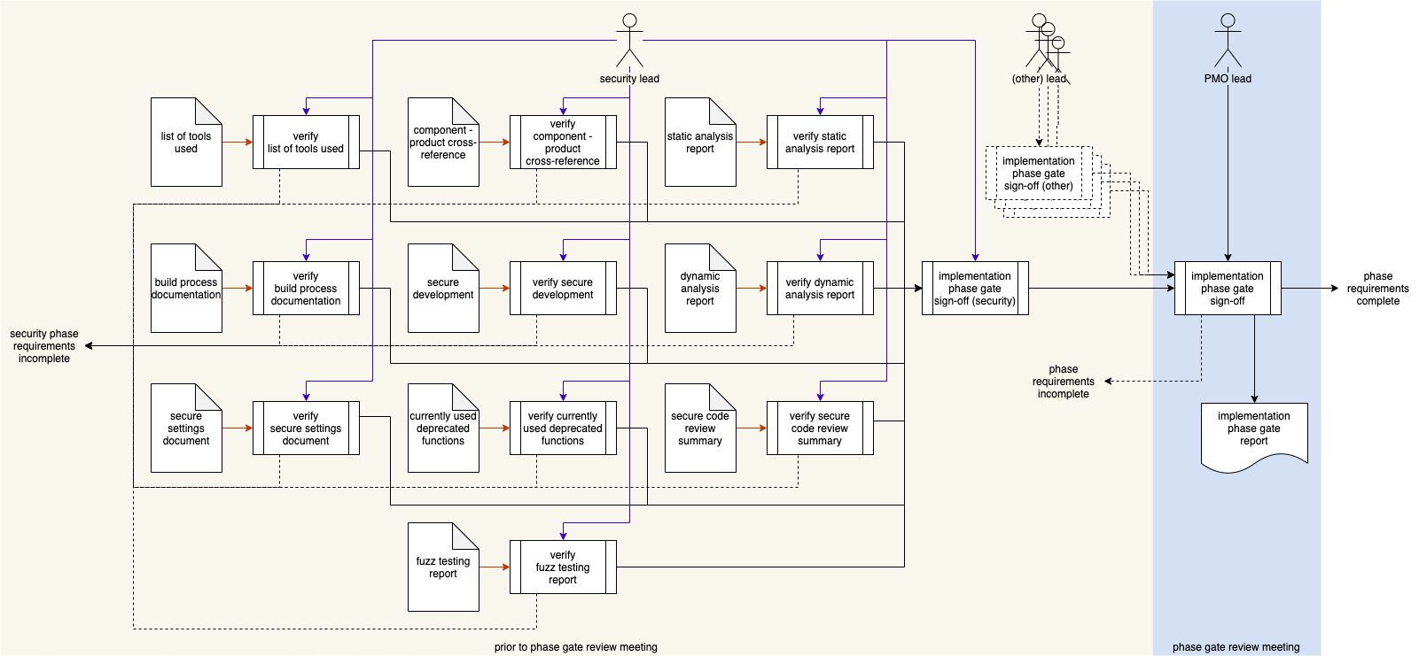

# Process

The following diagram is a taken from the implementation phase section of the **AVCDL** product dependencies graph.

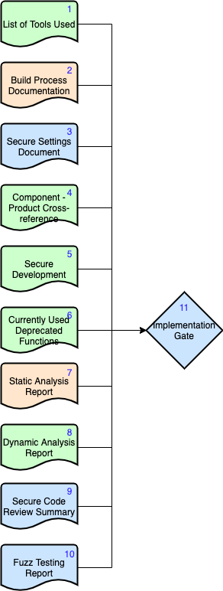

As shown by the blue numbers in the upper right corner of each element, we can see that the requirements phase gate has ten gated phase requirements with ten products.

**Note:** Activities stemming from non-dependent phase requirements may be undertaken in parallel.

The following phase requirement products need to be verified as completed for the gate to be signed off:

1. **List of Tools Used**
2. **Build Process Documentation**
3. **Secure Settings Document**
4. **Component – Product Cross-reference**
5. **Secure Development**
6. **Currently Used Deprecated Functions**
7. **Static Analysis Report**
8. **Dynamic Analysis Report**
9. **Secure Code Review Summary**
10. **Fuzz Testing Report**

The process is broadly divided into two parts: prior to the phase gate review meeting and the meeting itself. Activities taking place prior to the meeting are conducted separately by each group with a dependency on the gate. Failure during these activities precludes the meeting taking place, as any such failure would cause the gate to be failed.

## List of Tools Used Verification

|  |  |
| --- | --- |
| **Inputs** | List of Tools Used |
| **Outputs** | none |
| **Participants** | Security Lead |

The security lead verifies that the **List of Tools Used** phase requirements product for the element under consideration are complete. If they are not complete, the gate should not be entered and the PMO should be informed.

## Build Process Documentation Verification

|  |  |
| --- | --- |
| **Inputs** | Build Process Documentation |
| **Outputs** | none |
| **Participants** | Security Lead |

The security lead verifies that the **Build Process Documentation** phase requirements product for the element under consideration are complete. If they are not complete, the gate should not be entered and the PMO should be informed.

## Secure Settings Document Verification

|  |  |
| --- | --- |
| **Inputs** | Secure Settings Document |
| **Outputs** | none |
| **Participants** | Security Lead |

The security lead verifies that the **Secure Settings Document** phase requirements product for the element under consideration are complete. If they are not complete, the gate should not be entered and the PMO should be informed.

## Component – Product Cross-reference Verification

|  |  |
| --- | --- |
| **Inputs** | Component – Product Cross-reference |
| **Outputs** | none |
| **Participants** | Security Lead |

The security lead verifies that the **Component – Product Cross-reference** phase requirements product for the element under consideration are complete. If they are not complete, the gate should not be entered and the PMO should be informed.

## Secure Development

|  |  |
| --- | --- |
| **Inputs** | Fulfillment of Security Requirements |
| **Outputs** | none |
| **Participants** | Security Lead |

The security lead verifies that the **Secure Development** phase requirements product for the element under consideration are complete. If they are not complete, the gate should not be entered and the PMO should be informed.

## Currently Used Deprecated Functions Verification

|  |  |
| --- | --- |
| **Inputs** | Currently Used Deprecated Functions |
| **Outputs** | none |
| **Participants** | Security Lead |

The security lead verifies that the **Currently Used Deprecated Functions** phase requirements product for the element under consideration are complete. If they are not complete, the gate should not be entered and the PMO should be informed.

## Static Analysis Report Verification

|  |  |
| --- | --- |
| **Inputs** | Static Analysis Report |
| **Outputs** | none |
| **Participants** | Security Lead |

The security lead verifies that the **Static Analysis Report** phase requirements product for the element under consideration are complete. If they are not complete, the gate should not be entered and the PMO should be informed.

## Dynamic Analysis Report Verification

|  |  |
| --- | --- |
| **Inputs** | Dynamic Analysis Report |
| **Outputs** | none |
| **Participants** | Security Lead |

The security lead verifies that the **Dynamic Analysis Report** phase requirements product for the element under consideration are complete. If they are not complete, the gate should not be entered and the PMO should be informed.

## Secure Code Review Summary Verification

|  |  |
| --- | --- |
| **Inputs** | Secure Code Review Summary |
| **Outputs** | none |
| **Participants** | Security Lead |

The security lead verifies that the **Secure Code Review Summary** phase requirements product for the element under consideration are complete. If they are not complete, the gate should not be entered and the PMO should be informed.

## Fuzz Testing Report Verification

|  |  |
| --- | --- |
| **Inputs** | Fuzz Testing Report |
| **Outputs** | none |
| **Participants** | Security Lead |

The security lead verifies that the **Fuzz Testing Report** phase requirements product for the element under consideration are complete. If they are not complete, the gate should not be entered and the PMO should be informed.

## Implementation Phase Gate Signoff (Security)

|  |  |
| --- | --- |
| **Inputs** | none |
| **Outputs** | none |
| **Participants** | Security Lead |

The security lead signs off that all security-related products for this phase are complete and in good order. The PMO is informed of this.

## Implementation Phase Gate Signoff

|  |  |
| --- | --- |
| **Inputs** | none |
| **Outputs** | Implementation Phase Gate Report |
| **Participants** | PMO Lead |

If all participating groups provide signoffs the phase gate review meeting takes place. During this meeting all parties satisfy themselves that all their dependencies upon other groups are met. If there are no issues raised, the PMO lead signs off that all products for this phase are complete and in good order. Otherwise, the gate is not passed. The PMO produces the **Implementation Phase Gate Report** to document the gate outcome.

At a minimum, the report contains formal sign-off from each group’s lead with a list of the phase products verified.

# References

1. **AVCDL** Product Dependencies **(**in **AVCDL** main document**)**
2. **Implementation Phase Gate Report**
3. **List of Tools Used** (**AVCDL** secondary document)
4. **Build Process Documentation** (**AVCDL** secondary document)
5. **Secure Settings Document** (**AVCDL** secondary document)
6. **Component – Product Cross-reference** (**AVCDL** secondary document)
7. **Secure Development** (**AVCDL** secondary document)
8. **Currently Used Deprecated Functions** (**AVCDL** secondary document)
9. **Static Analysis Report** (**AVCDL** secondary document)
10. **Dynamic Analysis Report** (**AVCDL** secondary document)
11. **Secure Code Review Summary** (**AVCDL** secondary document)
12. **Fuzz Testing Report** (**AVCDL** secondary document)